**ALOHA TOURS AND TRAVELS**

**ABSTRACT**

Aloha Tours and Travels project provides great chances for users to obtain rich information. Particularly, tourists want to easily get tremendous information about their tourism plans. Therefore, in this paper, we aim to design a tourism resources management system and guide the tourists to plan their travel routes. In general if any user plans for any tour they must consult any traveling agency for purchasing package. At the same time the user has to do traveling reservations from source to destination, hotel reservations at destination place and other travel reservations from destination to other places, this involves lot of manual work. For all these type of reservations must be done by user by standing lot of time in a queue. To avoid these problems to reduce the manual work to the user new project was developed i.e. Aloha Tours and Travels.

**INTRODUCTION**

In recent years, with the improvement of people's living standards, more and more people travel. How to better manage scenic spot information has become the focus of tourism information management departments . Access to relevant and accurate information is at the heart of tourism, more so in this era of the Internet information overload has become a prevalent phenomenon and as such a serious issue for those seeking for appropriate information. Furthermore, various researches have been carried out on how to make information on tourism website more effective. Therefore, in this paper, we aim to design a tourism resources management system and guide the tourists to plan their travel routes. In general if any user plans for any tour they must consult any traveling agency for purchasing package. At the same time the user has to do traveling reservations from source to destination, hotel reservations at destination place and other travel reservations from destination to other places, this involves lot of manual work . So ,here the user can see the places and hotels and can book the hotels and can see the path from source address to the destination address.

**LITERATURE REVIEW**

***1. Qi Xianwen,*Discussion on the Teaching Implementation Plan of “Tourism Management Information System”*, vol. 2014, no. 6, pp. 133-135, 2021****.*

Tourism information management department is the manager and supervisor of tourism information, which bears great work pressure. How to help scenic spot managers grasp the scenic spot information in time, provide information timely and effectively, provide real-time information of scenic spots, and make guiding decisions for scenic spots, which puts forward urgent requirements for the information management of tourism information. With the development of tourism information system, enterprises urgently need to use a new way of "static and customized tourism information system" to meet the needs of tourism market.

**Chen Chongfu, "On the Design and Application of Tourism Management Information System", Tourism Overview: Second Half Month, no. 12, pp. 1, 2017.**

With the continuous improvement of people's quality of life, people's demand for tourism gradually increased. The traditional way of tourism and information management level has been unable to meet the current tourism needs of tourists. The development of information technology promotes the rapid development of tourism information technology, and tourism information system can greatly improve the quality of tourism services and management level. Through the analysis of tourism information management and development mode, this paper designs and optimizes the tourism management information system in combination with the market demand of tourists to develop the tourism management information system suitable for tourists, which can improve the quality of tourism management.

**Wen Jing, Hao Dazhi and Zhang Xiaofeng, "Research on the Intelligent Examination System Based on Genetic Algorithm", Science and Technology Communication, no. 22, pp. 2, 2017**

With the mutual integration of computer technology and education, promoting the reform of education and teaching network, online examination mode has gradually become an important means of new education measurement. The online examination system has basically realized the examinee answer, check and system group, and other functions, but there is a set of performance is not high, the examination such as the imperfection of the auxiliary function, in view of the above problem, this paper analyzes the group's related theory, using genetic algorithm as a smart group volume is determined, and genetic operation process of the group to carry on the design and improvement; At the same time, the system function and framework technology are deeply analyzed, the system function framework is established, and the intelligent test system is finally realized..

**Cao Xiaoyan, Sun Ying and Wang Chen, "Research on Freight Route Planning System Based on Genetic Algorithm", Electronic Technology and Software Engineering, no.**

Aiming at the problem of logistic division based on genetic algorithm, it is planned to study the improvement of logistic distribution methods. We first meet the requirements of the genetic algorithm of logistic development, use the division method to divide the delivery area of the gene, and formulate a functional delivery plan, which generally includes weight measurement, measurement time, customer value measurement, instrument measurement time, and the whole process index. We set weight goals and find the best way to improve genetic algorithm delivery.

**Sun Lina, "Development of Intelligent Examination System Based on Genetic Algorithm", Modern Information Technology, vol. 003, no. 001, pp. 83-85, 2019.**

Sun Lina, "Development of Intelligent Examination System Based on Genetic Algorithm", Modern Information Technology, vol. 003, no. 001, pp. 83-85, 2019.

Empowerment is a concept linked to power. It has been defined as the “ability to get what one wants, and the

ability to influence others to feel, act, and/or behave in ways that further one’s own interests” (Dodd and

Gutierrez 1990, p. 64) and “the capacity to exert control and influence over decisions that affects one’s life

space for one’s own benefit” (Zimmerman 2000, p. 44). Many researchers have described empowerment as an

iterative process of gaining such power (Speer and Hughey 1995; Masterson and Owen 2006; Wallis, Dukay,

Mellins et al. 2008). Empowerment has different meanings in different sociocultural and political contexts,

typically involving the use of terms such as self-efficacy, control, self-power, self-reliance, independence,

making one’s own decisions, and being free to define it (Narayan 2002). Empowerment is of intrinsic value and

can be applied at the individual and collective levels. In its broadest sense, empowerment is the expansion of

freedom of choice and action. It means increasing one’s authority and control over the resources and decisions

that affect one’s life. As people exercise real choice, they gain increased control over their lives.

Empowerment is a concept linked to power. It has been defined as the “ability to get what one wants, and the

ability to influence others to feel, act, and/or behave in ways that further one’s own interests” (Dodd and

Gutierrez 1990, p. 64) and “the capacity to exert control and influence over decisions that affects one’s life

space for one’s own benefit” (Zimmerman 2000, p. 44). Many researchers have described empowerment as an

iterative process of gaining such power (Speer and Hughey 1995; Masterson and Owen 2006; Wallis, Dukay,

Mellins et al. 2008). Empowerment has different meanings in different sociocultural and political contexts,

typically involving the use of terms such as self-efficacy, control, self-power, self-reliance, independence,

making one’s own decisions, and being free to define it (Narayan 2002). Empowerment is of intrinsic value and

can be applied at the individual and collective levels. In its broadest sense, empowerment is the expansion of

freedom of choice and action. It means increasing one’s authority and control over the resources and decisions

that affect one’s life. As people exercise real choice, they gain increased control over their lives.

Empowerment is a concept linked to power. It has been defined as the “ability to get what one wants, and the

ability to influence others to feel, act, and/or behave in ways that further one’s own interests” (Dodd and

Gutierrez 1990, p. 64) and “the capacity to exert control and influence over decisions that affects one’s life

space for one’s own benefit” (Zimmerman 2000, p. 44). Many researchers have described empowerment as an

iterative process of gaining such power (Speer and Hughey 1995; Masterson and Owen 2006; Wallis, Dukay,

Mellins et al. 2008). Empowerment has different meanings in different sociocultural and political contexts,

typically involving the use of terms such as self-efficacy, control, self-power, self-reliance, independence,

making one’s own decisions, and being free to define it (Narayan 2002). Empowerment is of intrinsic value and

can be applied at the individual and collective levels. In its broadest sense, empowerment is the expansion of

freedom of choice and action. It means increasing one’s authority and control over the resources and decisions

that affect one’s life. As people exercise real choice, they gain increased control over their lives.

Empowerment is a concept linked to power. It has been defined as the “ability to get what one wants, and the

ability to influence others to feel, act, and/or behave in ways that further one’s own interests” (Dodd and

Gutierrez 1990, p. 64) and “the capacity to exert control and influence over decisions that affects one’s life

space for one’s own benefit” (Zimmerman 2000, p. 44). Many researchers have described empowerment as an

iterative process of gaining such power (Speer and Hughey 1995; Masterson and Owen 2006; Wallis, Dukay,

Mellins et al. 2008). Empowerment has different meanings in different sociocultural and political contexts,

typically involving the use of terms such as self-efficacy, control, self-power, self-reliance, independence,

making one’s own decisions, and being free to define it (Narayan 2002). Empowerment is of intrinsic value and

can be applied at the individual and collective levels. In its broadest sense, empowerment is the expansion of

freedom of choice and action. It means increasing one’s authority and control over the resources and decisions

that affect one’s life. As people exercise real choice, they gain increased control over their lives.

Empowerment is a concept linked to power. It has been defined as the “ability to get what one wants, and the

ability to influence others to feel, act, and/or behave in ways that further one’s own interests” (Dodd and

Gutierrez 1990, p. 64) and “the capacity to exert control and influence over decisions that affects one’s life

space for one’s own benefit” (Zimmerman 2000, p. 44). Many researchers have described empowerment as an

iterative process of gaining such power (Speer and Hughey 1995; Masterson and Owen 2006; Wallis, Dukay,

Mellins et al. 2008). Empowerment has different meanings in different sociocultural and political contexts,

typically involving the use of terms such as self-efficacy, control, self-power, self-reliance, independence,

making one’s own decisions, and being free to define it (Narayan 2002). Empowerment is of intrinsic value and

can be applied at the individual and collective levels. In its broadest sense, empowerment is the expansion of

freedom of choice and action. It means increasing one’s authority and control over the resources and decisions

that affect one’s life. As people exercise real choice, they gain increased control over their lives.

Empowerment is a concept linked to power. It has been defined as the “ability to get what one wants, and the

ability to influence others to feel, act, and/or behave in ways that further one’s own interests” (Dodd and

Gutierrez 1990, p. 64) and “the capacity to exert control and influence over decisions that affects one’s life

space for one’s own benefit” (Zimmerman 2000, p. 44). Many researchers have described empowerment as an

iterative process of gaining such power (Speer and Hughey 1995; Masterson and Owen 2006; Wallis, Dukay,

Mellins et al. 2008). Empowerment has different meanings in different sociocultural and political contexts,

typically involving the use of terms such as self-efficacy, control, self-power, self-reliance, independence,

making one’s own decisions, and being free to define it (Narayan 2002). Empowerment is of intrinsic value and

can be applied at the individual and collective levels. In its broadest sense, empowerment is the expansion of

freedom of choice and action. It means increasing one’s authority and control over the resources and decisions

that affect one’s life. As people exercise real choice, they gain increased control over their lives.

Empowerment theory provides a framework that helps to organise the knowledge needed to create strategies to

support the development of empowerment. The theory suggests that actions, activities or structures may be

empowering, and the outcome of each process results in a level of being empowered (Zimmerman 1988). A

thorough development of empowerment theory requires exploration and description at multiple levels of

analysis such as individual, organisational and community. Applying this general framework to community

level analysis, empowerment may refer to collective action to improve the quality of life in a community and to

the connections among community organisations and agencies. This can provide the basis to investigate how

users can form into communities similar to the “group” concept in current Social Networks. In empowerment

theory, empowering processes and their outcomes are clearly defined. Empowering processes for individuals

might include learning decision-making skills, managing resources and working with others. Empowering

processes for communities might include being able to access government agencies, media and other community

resources. Possible outcomes of individuals feeling “empowered” would be situation specific perceived control,

critical awareness, skills and proactive behaviours. For communities, empowerment outcomes might include the

evidence of pluralism, the existence of organisational coalition and accessible community resources.

The rapid development of the Internet has brought tremendous changes to people’s lives. Through the network function, the online examination is gradually accepted by various educational and teaching institutions. Currently, online exams have become the main method of teaching evaluation. In order to solve the problem of intelligent test paper more effectively, this paper proposes a mufti-threaded intelligent test paper strategy based on genetic algorithm, and designs the computer system structure in the standard test question bank. Convergence simulation and experimental results show that the algorithm is better than simple particle swarm optimization algorithm, simple genetic algorithm and its improved algorithm.

**EXISTING METHOD**

In the existing system, all the records are not kept perfectly because all the work is done manually, so keeping up to date details of the places is not perfectly followed .User can view the places and need to search for he places and book the places. Manually a person has to go and search for the places in a particular place ,it will take a lot of time to do such process, in the existing system. It will consumes money also.

**Drawbacks:**

* It is time consuming.
* Manual searching.
* Data is secured.

**PROPOSED METHOD**

Aloha Tours and Travels is the project which gives all the required facilities to their customers when they are ready to plan for any tour. By using this portal the user can book any places and also it provides help to the users .User can book the places and give the review regarding to that tour. Then other users can easily get the feedback of that place by viewing the review.

**Advantages:**

* Data will be stored systematically and accurately.
* Computerized work.
* Easy to analyze the tours and reviews
* Reducing the transport cost.

**PROPOSED METHOD**

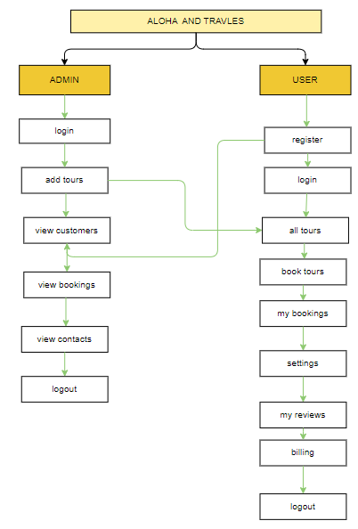

**Block diagram of proposed method**

**IMPLEMENTATION**

* Install the required packages
* Defining the problem association.
* Runs admin and user modules.

**HARDWARE & SOFTWARE REQUIREMENTS**

# H/W SYSTEM CONFIGURATION:-

# Processor - I3/Intel Processor

* RAM - 4GB (min)
* Hard Disk - 160GB
* Key Board - Standard Windows Keyboard
* Mouse - Two or Three Button Mouse
* Monitor - SVGA

**S/W SYSTEM CONFIGURATION:-**

* Operating System : Windows 7/8/10
* Application Server : Tomcat 9.0
* Front End : React js ,Html, Css
* Scripts : JavaScript.
* Technology : Node Js
* Database : MOngoDb
* Database Connectivity : JDBC

**ARCHITECTURE**

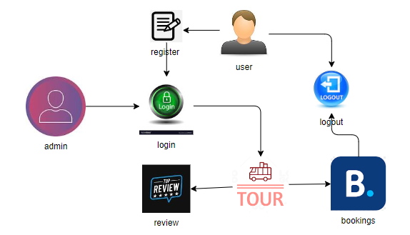

**SOFTWARE INSTALLATION FOR JAVA PROJECTS**

This Java Development Kit(JDK) allows you to code and run Java programs. It's possible that you install multiple JDK versions on the same PC. But It’s recommended that you install only latest version.

## How to install Java for Windows

Following are the steps for JDK 8 free download for 32 bit or JDK 8 download 64 bit and installation

**Step 1)** Go to [link](https://www.oracle.com/java/technologies/javase-downloads.html). Click on JDK Download for Java

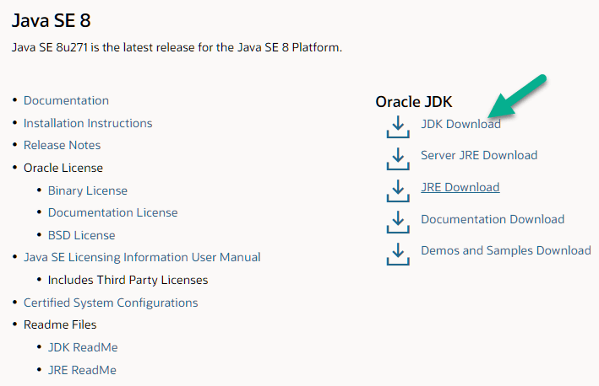

**Step 2)** Next,

1. Accept License Agreement
2. Download Java 8 JDK for your version 32 bit or JDK 8 download for windows 10 64 bit.

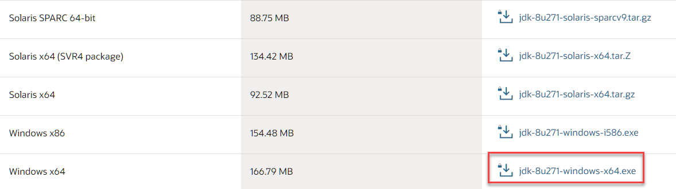

**Step 3)** when you click on the Installation link the popup will be open. Click on I reviewed and accept the Oracle Technology Network License Agreement for Oracle Java SE and you will be redirected to the login page. If you don't have an oracle account you can easily sign up by adding basics details of yours.

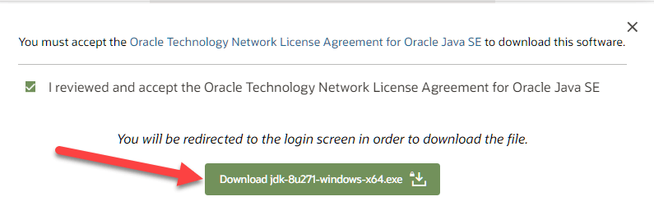

**Step 4)** Once the Java JDK 8 download is complete, run the exe for install JDK. Click Next

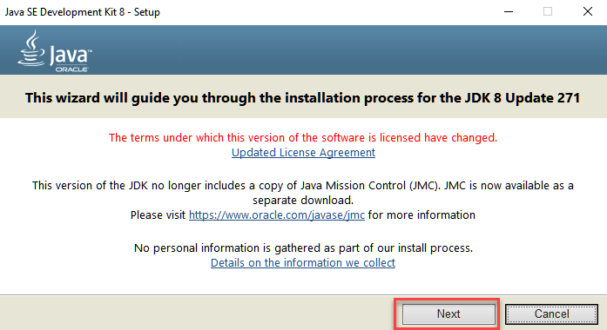

**Step 5)** Select the PATH to install Java in Windows and click next.

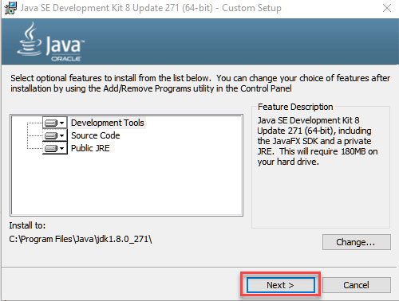

**Step 6)** Once you install Java in windows, click close

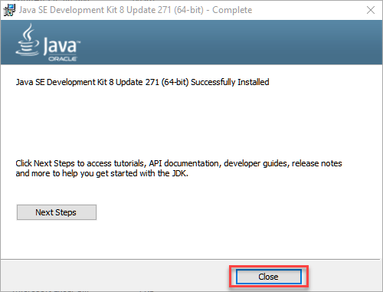

## How to set Environment Variables in Java: Path and Class path

The PATH variable gives the location of executable like javac, java etc. It is possible to run a program without specifying the PATH but you will need to give full path of executable like **C:\Program Files\Java\jdk-13.0.1\bin\javac A.java** instead of simple **javac A.java**

The CLASSPATH variable gives location of the Library Files.

Let's look into the steps to set the PATH and CLASSPATH

**Step 1)** Right Click on the My Computer and Select the properties



**Step 2)** Click on advanced system settings

**Step 3)** Click on Environment Variables

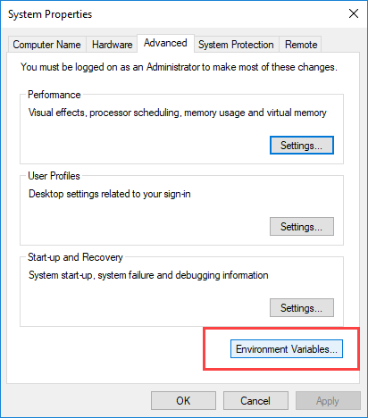

**Step 4)** Click on new Button of User variables

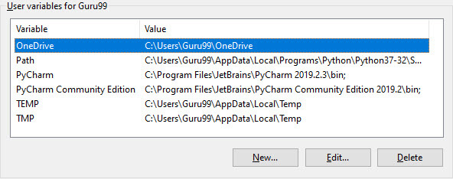

**Step 5)** Type PATH in the Variable name.

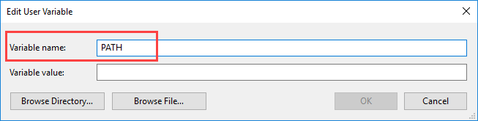

**Step 6)** Copy the path of bin folder which is installed in JDK folder.

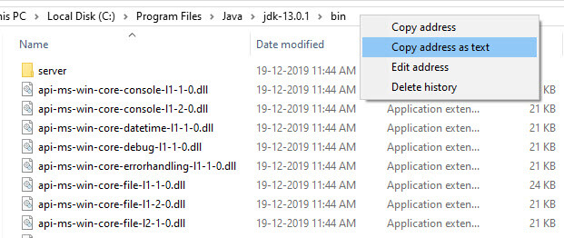

**Step 7)** Paste Path of bin folder in Variable value and click on OK Button.

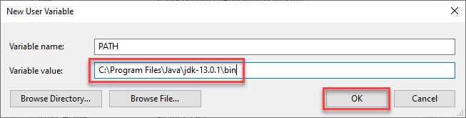

**Note:** In case you already have a PATH variable created in your PC, edit the PATH variable to

PATH = <JDK installation directory>\bin;%PATH%;

Here, %PATH% appends the existing path variable to our new value

**Step 8)**You can follow a similar process to set CLASSPATH.

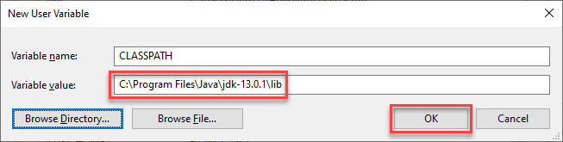

**Note:** In case you java installation does not work after installation, change classpath to

CLASSPATH = <JDK installation directory>\lib\tools.jar;

**Step 9)** Click on OK button

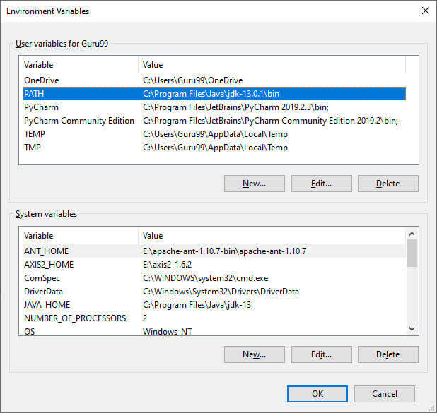

**Step 10)** Go to command prompt and type javac commands.

If you see a screen like below, Java is installed.

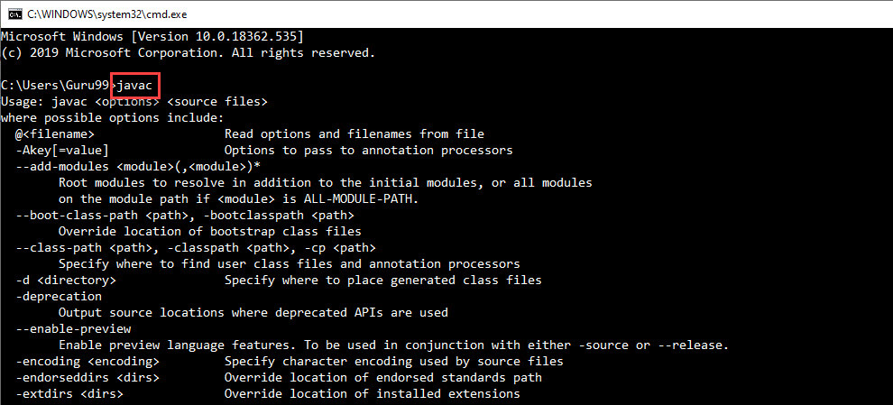

**INSTALLING JAVA AND INTELLIJ IDEA**

**Installing java:**

This Java Development Kit(JDK) allows you to code and run Java programs. It's possible that you install multiple JDK versions on the same PC. But It’s recommended that you install only latest version.

## How to install Java for Windows

Following are the steps for JDK 8 free download for 32 bit or JDK 8 download 64 bit and installation

**Step 1)** Go to [link](https://www.oracle.com/java/technologies/javase-downloads.html). Click on JDK Download for Java



**Step 2)** Next,

1. Accept License Agreement
2. Download Java 8 JDK for your version 32 bit or JDK 8 download for windows 10 64 bit.



**Step 3)** when you click on the Installation link the popup will be open. Click on I reviewed and accept the Oracle Technology Network License Agreement for Oracle Java SE and you will be redirected to the login page. If you don't have an oracle account you can easily sign up by adding basics details of yours.



**Step 4)** once the Java JDK 8 download is complete, run the exe for install JDK. Click Next



**Step 5)** Select the PATH to install Java in Windows and click next.



**Step 6)** Once you install Java in windows, click close



## How to set Environment Variables in Java: Path and Class path

The PATH variable gives the location of executable like javac, java etc. It is possible to run a program without specifying the PATH but you will need to give full path of executable like **C:\Program Files\Java\jdk-13.0.1\bin\javac A.java** instead of simple **javac A.java**

The CLASSPATH variable gives location of the Library Files.

Let's look into the steps to set the PATH and CLASSPATH

**Step 1)** Right Click on the My Computer and Select the properties



**Step 2)** Click on advanced system settings

**Step 3)** Click on Environment Variables



**Step 4)** Click on new Button of User variables



**Step 5)** Type PATH in the Variable name.



**Step 6)** Copy the path of bin folder which is installed in JDK folder.



**Step 7)** Paste Path of bin folder in Variable value and click on OK Button.



**Note:** In case you already have a PATH variable created in your PC, edit the PATH variable to

PATH = <JDK installation directory>\bin;%PATH%;

Here, %PATH% appends the existing path variable to our new value

**Step 8)**You can follow a similar process to set CLASSPATH.



**Note:** In case you java installation does not work after installation, change classpath to

CLASSPATH = <JDK installation directory>\lib\tools.jar;

**Step 9)** Click on OK button



**Step 10)** Go to command prompt and type javas commands.

If you see a screen like below, Java is installed.



Installing intellij idea:

1. To download Intellij visit the website https://www.jetbrains.com/idea/download/#section=windows and Click the "DOWNLOAD" link under the Community Section.

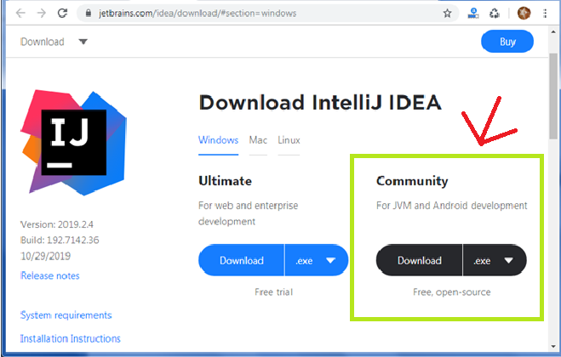

1. Once the download is complete, run the exe for install Intellij. The setup wizard should have started. Click “Next”.
2. On the next screen, Change the installation path if required. Click “Next”.
3. On the next screen, you can create a desktop shortcut if you want and click on “Next”.
4. Choose the start menu folder. Keep selected Jet Brains and click on “Install”.
5. Wait for the installation to finish.
6. Once installation finished, you should receive a message screen that Intellij is installed. If you want to go ahead and run it, click the “Run Intellij Community Edition” box first and click “Finish”.
7. After you click on "Finish," the Following screen will appear.

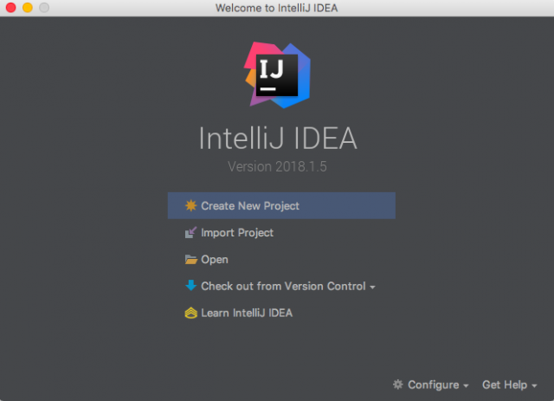

**Installing visual studio code**

Steps to installing visual studio code:

Step 1: Head over to the website <https://code.visualstudio.com/download>

Step2:choose the option as per your choice.

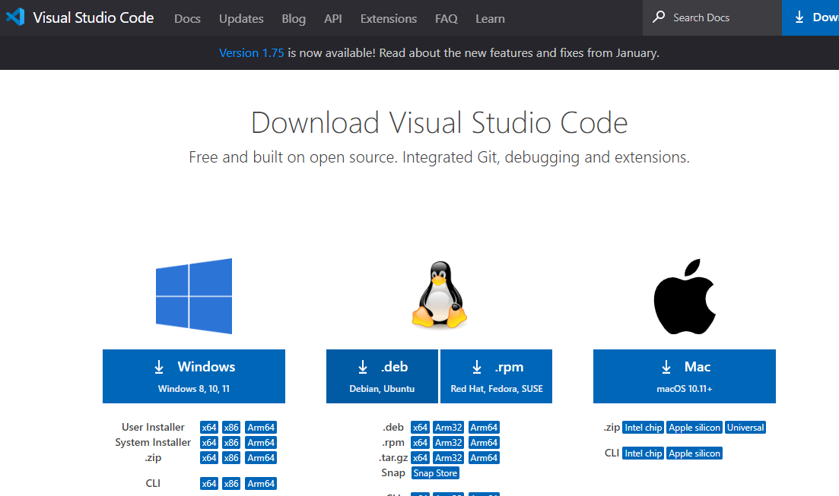

Step 3: Once download completed,open it and your screen will appear like this

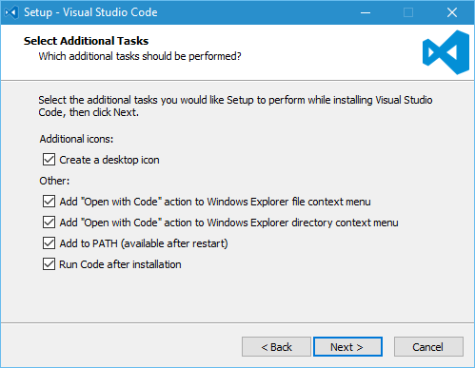

Step 4: click next until you saw the below page

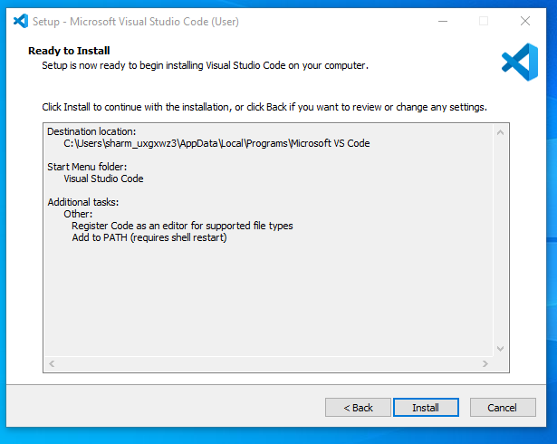

Step 4: After installation your screen will appear like this ,click finish and continue.

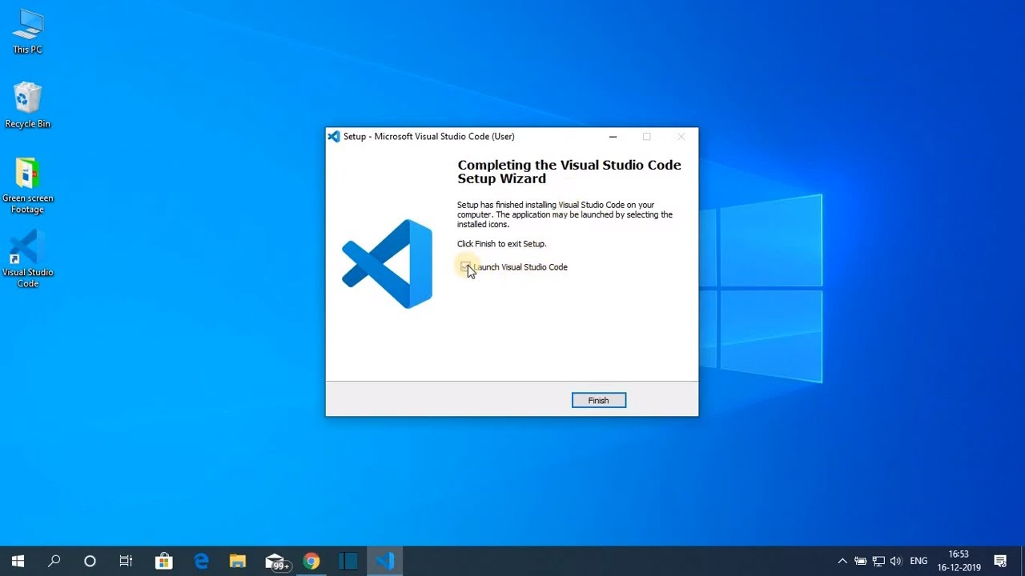

**Installing mysql**

Step 1: Go to the official website <https://www.mysql.com/downloads/>

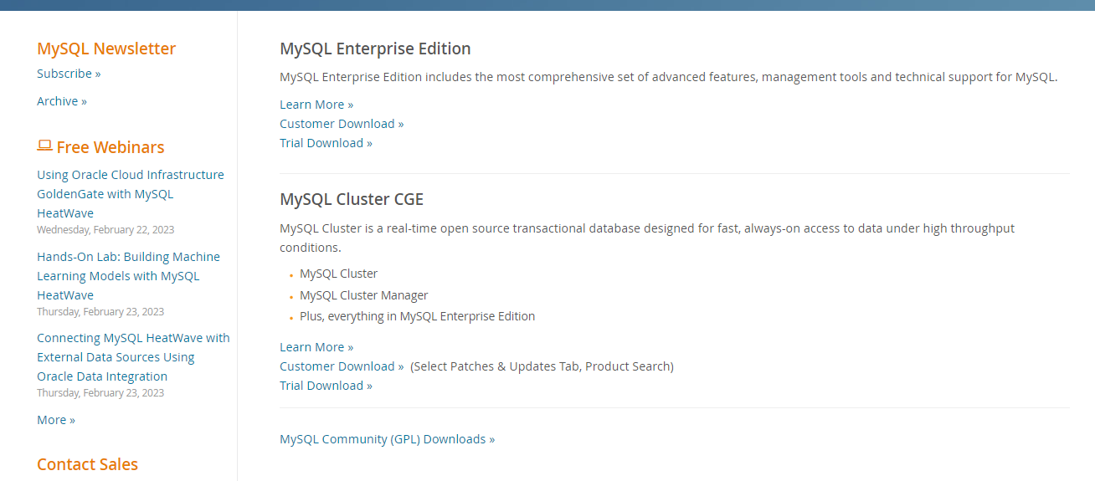

Step 2: click on the Mysql commu community downloads

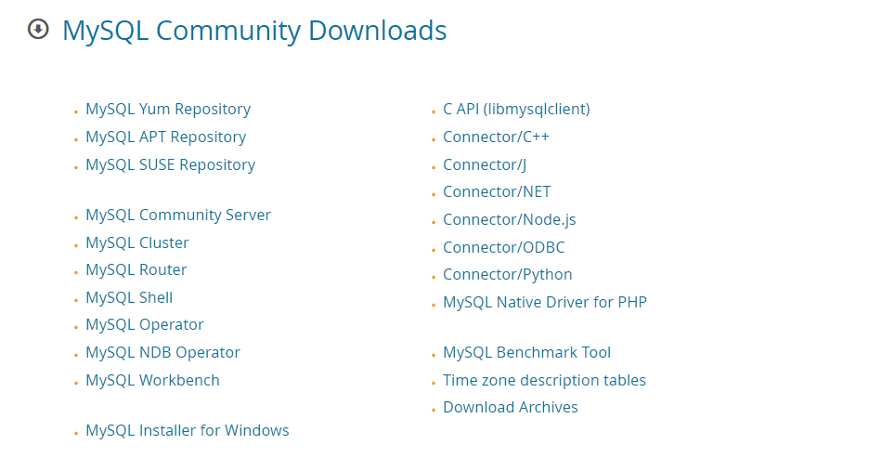

Step 3: click on Mysql installer for windows.

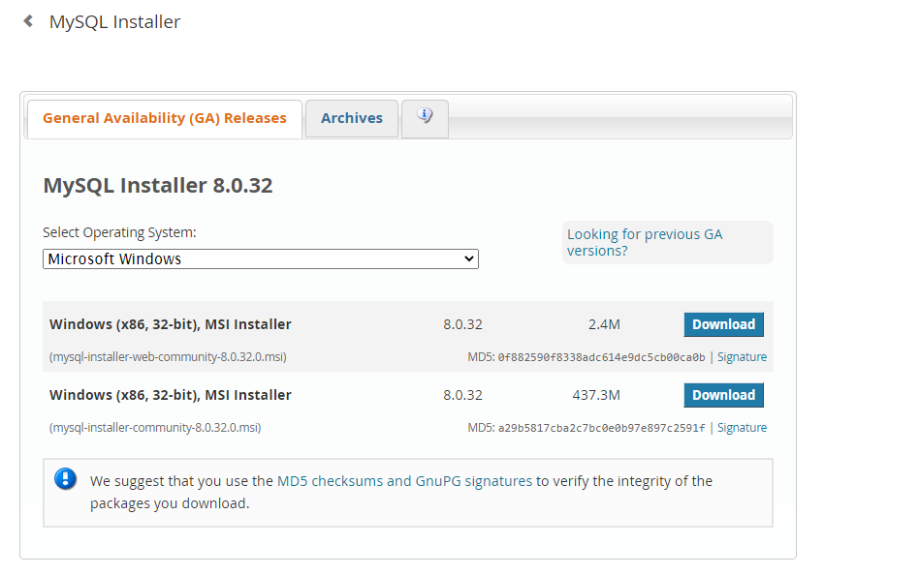

Step 4:click on the download at the bottom.

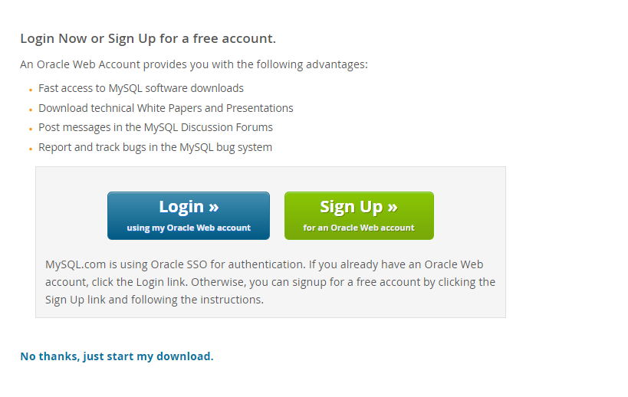

Step 5:click on No thanks, just start my download. Mysql will start downloading.After download is completed,open it and your screen will appear like this and choose custom from the following options and click next.

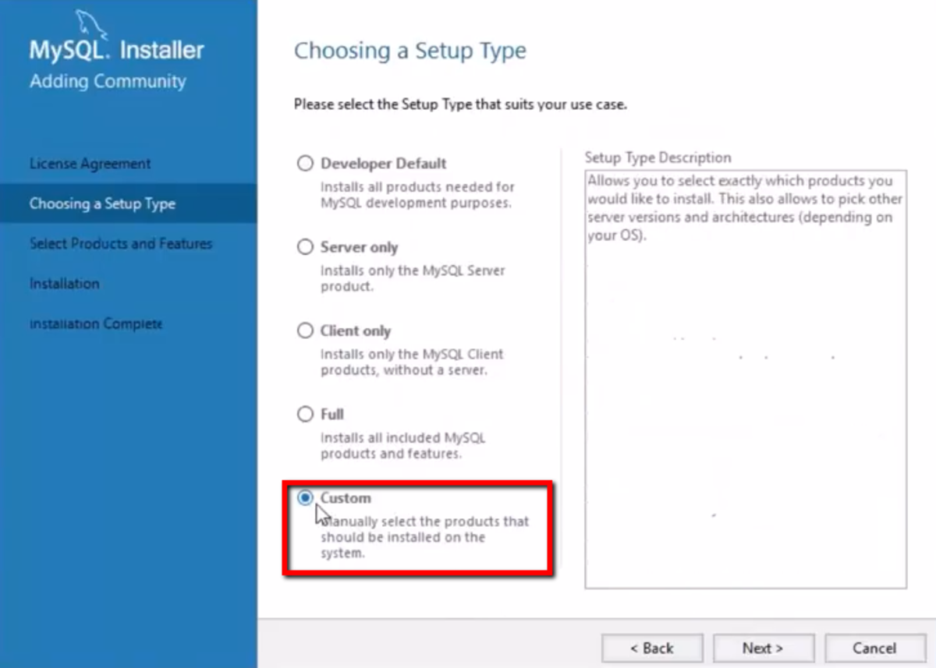

Step 6: choose server,workbench and shell and click arrow mark to add the following packages and click next.

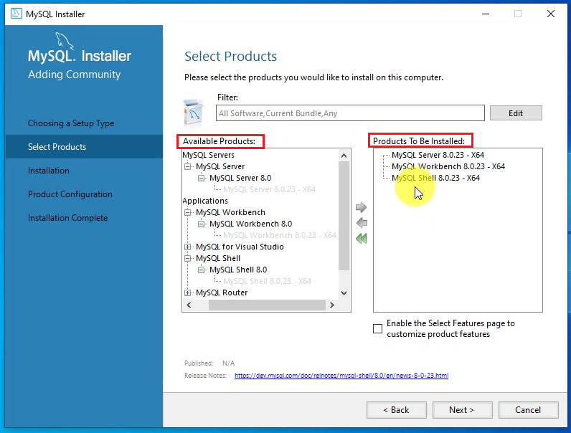

Step 7: click on execute and your download will be started.

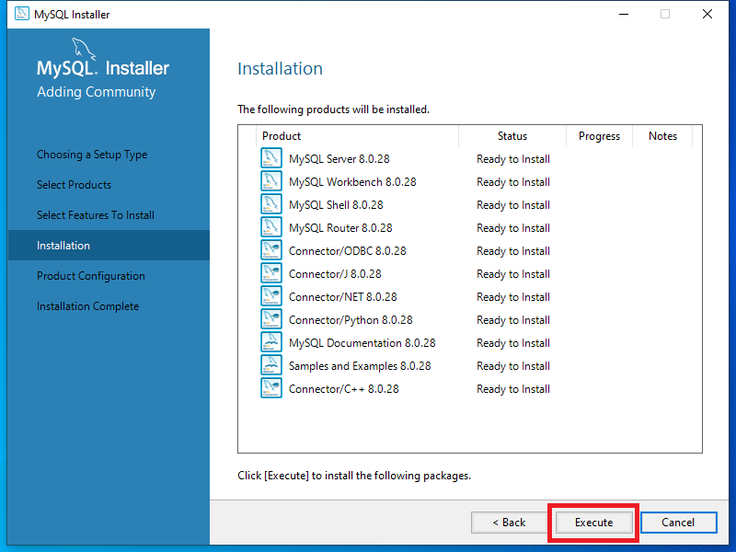

Step 8: Once completed your screen will appear like this.

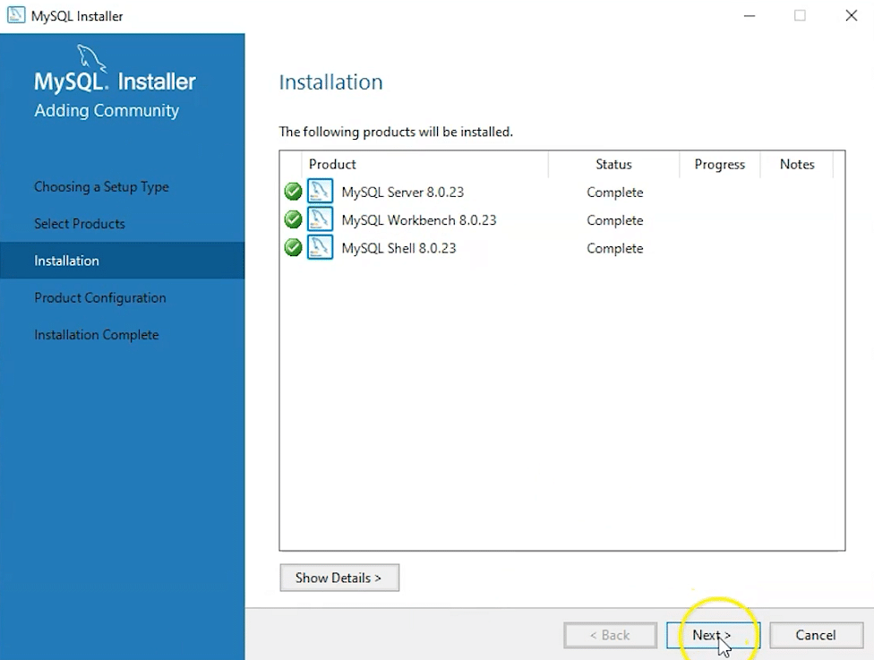

Step 9: click next and set the port number as 3306 .

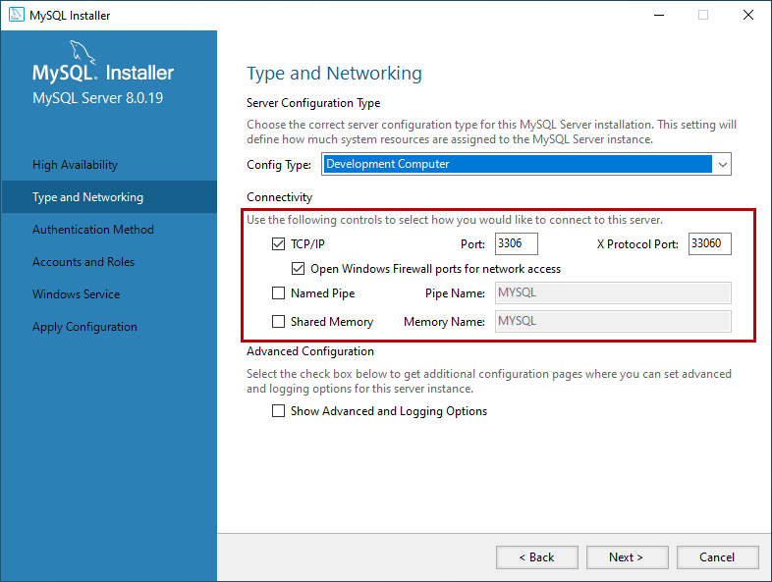

Step 10: select use strong password and click next.

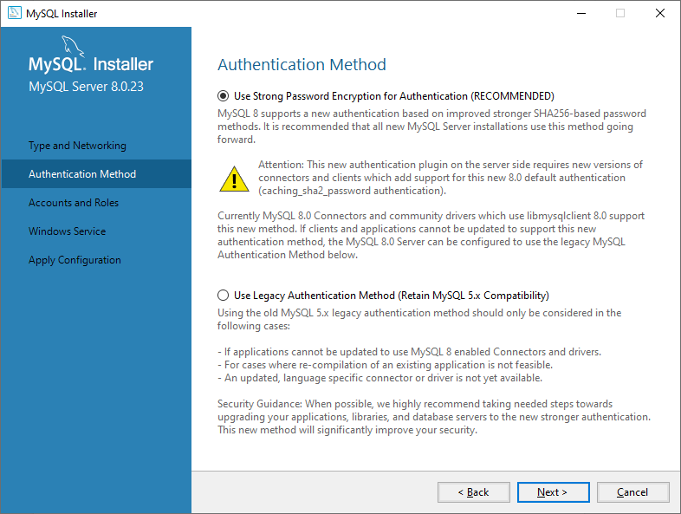

Step 11: set password and click next.

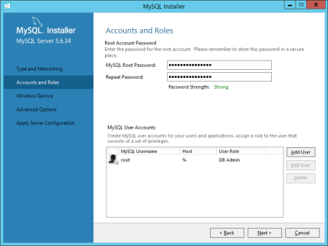

Step 12: set Mysql service name as MYSQL80.

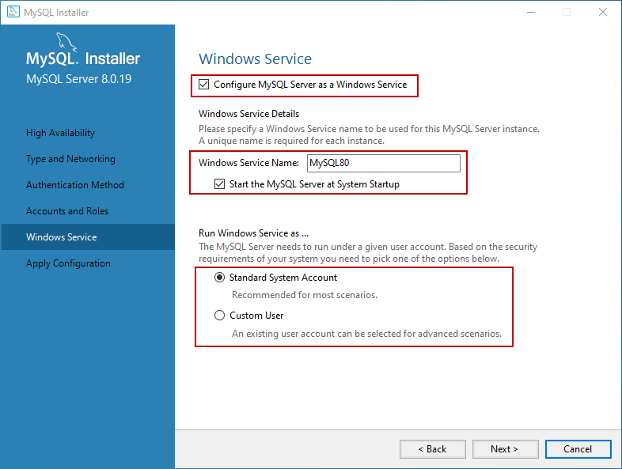

Step 13: select default and click on next.

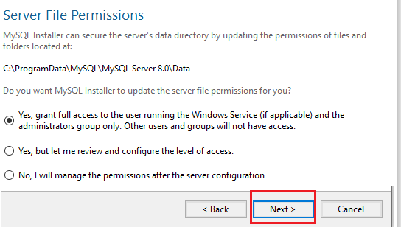

Step 14: click on execute and it will finish executing.

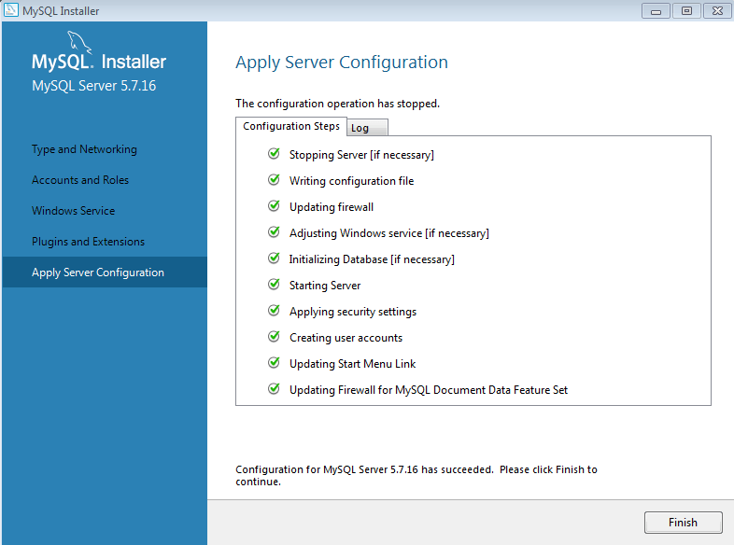

Step 15: click on next.

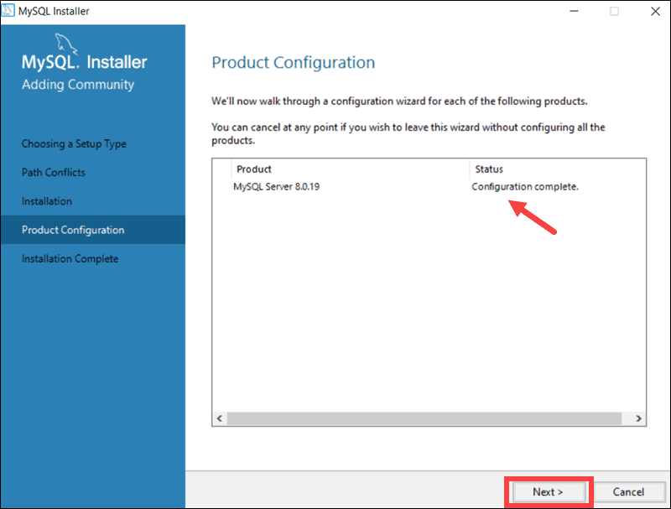

Step 16:click on finish.

**SYSTEM ANALYSIS**

**MODULES:**

**1. Admin:**

Admin login with their credentials. Admin can add the details of tourist place that can view the customers .

**View Tours:** Admin can view the tours added by him

**View Customers:** Admin can view the newly added customers .

**View Bookings:** Admin can view all the bookings that are done by the customer.

**2. User:**

User can register and login with the correct credentials, user can view the places, that are added by the admin

**Book Tour:** User can book the tour that are added by the admin. After book the tour user need to pay amount for the booking. User able to give the review for the particular tourist place.

**My bookings:**  After booking completed user can view the booking that are done by him/her.

**Settings:** User can change the profile by changing their details and by adding photo.

**My Reviews:**  User can view the reviews that are give by him/her.

**Billing:**  User can able to view the billing details.

**SYSTEM DESIGN**

**UML DIAGRAMS**

UML stands for Unified Modeling Language. UML is a standardized general-purpose modeling language in the field of object-oriented software engineering. The standard is managed, and was created by, the Object Management Group.

The goal is for UML to become a common language for creating models of object oriented computer software. In its current form UML is comprised of two major components: a Meta-model and a notation. In the future, some form of method or process may also be added to; or associated with, UML.

The Unified Modeling Language is a standard language for specifying, Visualization, Constructing and documenting the artifacts of software system, as well as for business modeling and other non-software systems.

The UML represents a collection of best engineering practices that have proven successful in the modeling of large and complex systems.

The UML is a very important part of developing objects oriented software and the software development process. The UML uses mostly graphical notations to express the design of software projects.

**GOALS:**

The Primary goals in the design of the UML are as follows:

1. Provide users a ready-to-use, expressive visual modeling Language so that they can develop and exchange meaningful models.
2. Provide extendibility and specialization mechanisms to extend the core concepts.
3. Be independent of particular programming languages and development process.
4. Provide a formal basis for understanding the modeling language.
5. Encourage the growth of OO tools market.
6. Support higher level development concepts such as collaborations, frameworks, patterns and components.
7. Integrate best practices.

**USE CASE DIAGRAM:**

A use case diagram in the Unified Modeling Language (UML) is a type of behavioral diagram defined by and created from a Use-case analysis. Its purpose is to present a graphical overview of the functionality provided by a system in terms of actors, their goals (represented as use cases), and any dependencies between those use cases. The main purpose of a use case diagram is to show what system functions are performed for which actor. Roles of the actors in the system can be depicted.

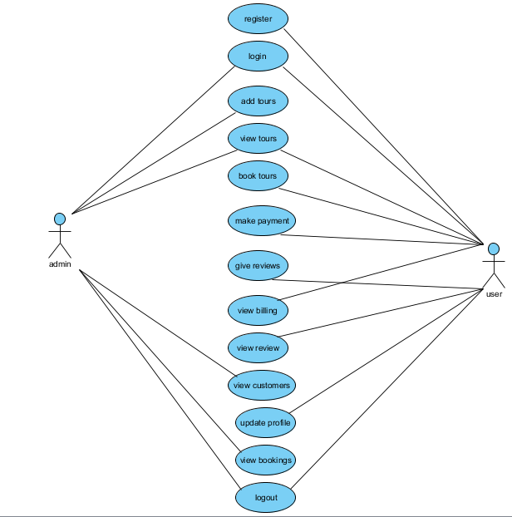

**CLASS DIAGRAM:**

In software engineering, a class diagram in the Unified Modeling Language (UML) is a type of static structure diagram that describes the structure of a system by showing the system's classes,their attributes, operations (or methods), and the relationships among the classes. It explains which class contains information.

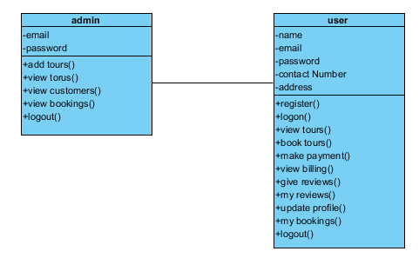

**SEQUENCE DIAGRAM:**

A sequence diagram in Unified Modeling Language (UML) is a kind of interaction diagram that shows how processes operate with one another and in what order. It is a construct of a Message Sequence Chart. Sequence diagrams are sometimes called event diagrams, event scenarios.

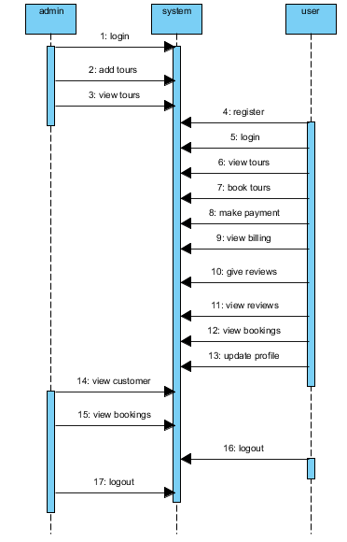

**COLLABORATION DIAGRAM:**

In collaboration diagram the method call sequence is indicated by some numbering technique as shown below. The number indicates how the methods are called one after another. We have taken the same order management system to describe the collaboration diagram. The method calls are similar to that of a sequence diagram. But the difference is that the sequence diagram does not describe the object organization whereas the collaboration diagram shows the object organization.

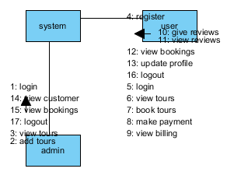

**DEPLOYMENT DIAGRAM:**

Deployment diagram represents the deployment view of a system. It is related to the component diagram. Because the components are deployed using the deployment diagrams. A deployment diagram consists of nodes. Nodes are nothing but physical hardware’s used to deploy the application.

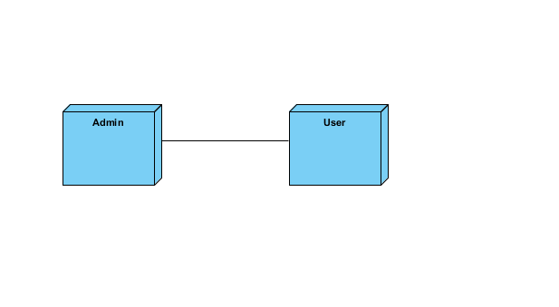

**ACTIVITY DIAGRAM:**

Activity diagrams are graphical representations of workflows of stepwise activities and actions with support for choice, iteration and concurrency. In the Unified Modeling Language, activity diagrams can be used to describe the business and operational step-by-step workflows of components in a system. An activity diagram shows the overall flow of control.

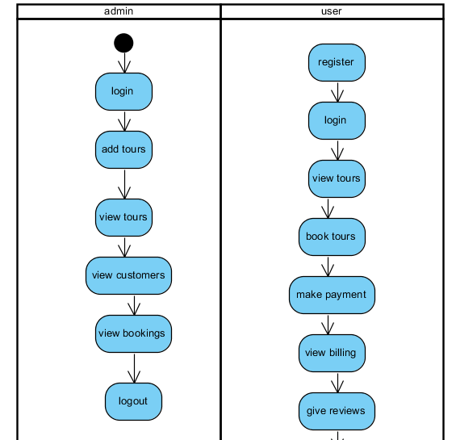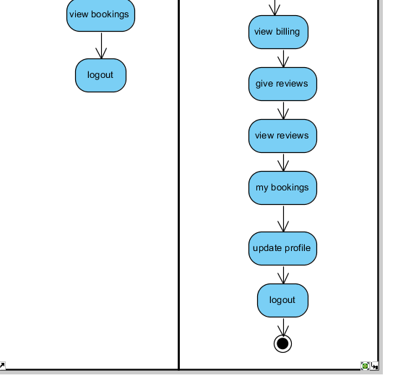

**COMPONENT DIAGRAM**:

A component diagram, also known as a UML component diagram, describes the organization and wiring of the physical **c**omponents in a system. Component diagrams are often drawn to help model implementation details and double-check that every aspect of the system's required functions is covered by planned development.

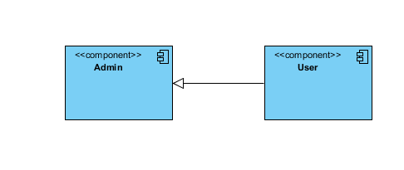

**ER Diagram:**

An Entity–relationship model (ER model) describes the structure of a database with the help of a diagram, which is known as Entity Relationship Diagram (ER Diagram). An ER model is a design or blueprint of a database that can later be implemented as a database. The main components of E-R model are: entity set and relationship set.

An ER diagram shows the relationship among entity sets. An entity set is a group of similar entities and these entities can have attributes. In terms of DBMS, an entity is a table or attribute of a table in database, so by showing relationship among tables and their attributes, ER diagram shows the complete logical structure of a database. Let’s have a look at a simple ER diagram to understand this concept.

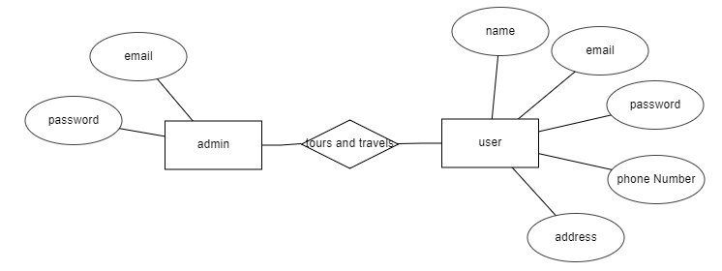

**DFD Diagram:**

A Data Flow Diagram (DFD) is a traditional way to visualize the information flows within a system. A neat and clear DFD can depict a good amount of the system requirements graphically. It can be manual, automated, or a combination of both. It shows how information enters and leaves the system, what changes the information and where information is stored. The purpose of a DFD is to show the scope and boundaries of a system as a whole. It may be used as a communications tool between a systems analyst and any person who plays a part in the system that acts as the starting point for redesigning a system.

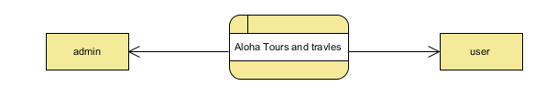

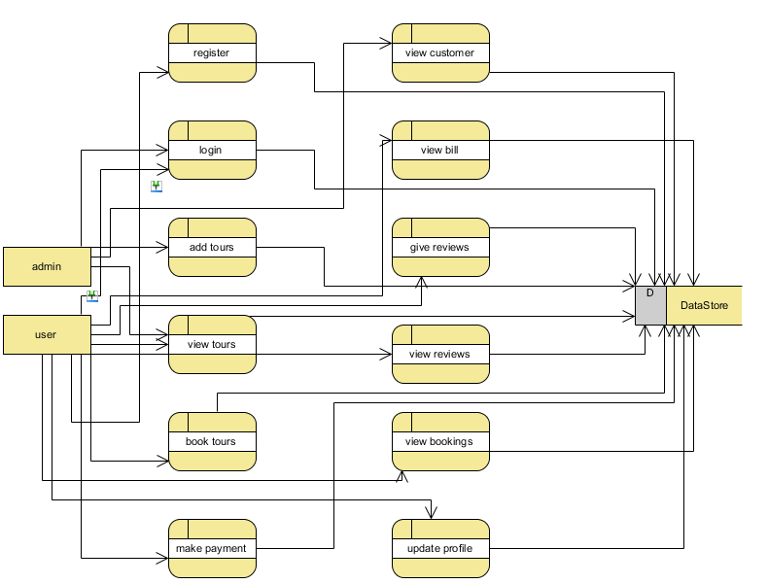

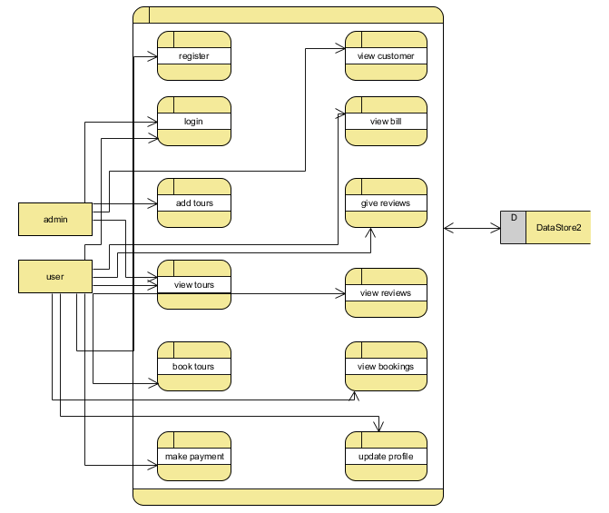

**SOFTWARE ENVIRONMENT**

This Java Development Kit(JDK) allows you to code and run Java programs. It's possible that you install multiple JDK versions on the same PC. But It’s recommended that you install only latest version.

## How to install Java for Windows

Following are the steps for JDK 8 free download for 32 bit or JDK 8 download 64 bit and installation

**Step 1)** Go to [link](https://www.oracle.com/java/technologies/javase-downloads.html). Click on JDK Download for Java



**Step 2)** Next,

1. Accept License Agreement
2. Download Java 8 JDK for your version 32 bit or JDK 8 download for windows 10 64 bit.



**Step 3)** when you click on the Installation link the popup will be open. Click on I reviewed and accept the Oracle Technology Network License Agreement for Oracle Java SE and you will be redirected to the login page. If you don't have an oracle account you can easily sign up by adding basics details of yours.



**Step 4)** Once the Java JDK 8 download is complete, run the exe for install JDK. Click Next



**Step 5)** Select the PATH to install Java in Windows and click next.



**Step 6)** Once you install Java in windows, click close



## How to set Environment Variables in Java: Path and Class path

The PATH variable gives the location of executable like javac, java etc. It is possible to run a program without specifying the PATH but you will need to give full path of executable like **C:\Program Files\Java\jdk-13.0.1\bin\javac A.java** instead of simple **javac A.java**

The CLASSPATH variable gives location of the Library Files.

Let's look into the steps to set the PATH and CLASSPATH

**Step 1)** Right Click on the My Computer and Select the properties



**Step 2)** Click on advanced system settings

**Step 3)** Click on Environment Variables



**Step 4)** Click on new Button of User variables



**Step 5)** Type PATH in the Variable name.



**Step 6)** Copy the path of bin folder which is installed in JDK folder.



**Step 7)** Paste Path of bin folder in Variable value and click on OK Button.



**Note:** In case you already have a PATH variable created in your PC, edit the PATH variable to

PATH = <JDK installation directory>\bin;%PATH%;

Here, %PATH% appends the existing path variable to our new value

**Step 8)**You can follow a similar process to set CLASSPATH.



**Note:** In case you java installation does not work after installation, change classpath to

CLASSPATH = <JDK installation directory>\lib\tools.jar;

**Step 9)** Click on OK button



**Step 10)** Go to command prompt and type javac commands.

If you see a screen like below, Java is installed.



**INSTALLING JAVA AND INTELLIJ IDEA**

**Installing java:**

This Java Development Kit(JDK) allows you to code and run Java programs. It's possible that you install multiple JDK versions on the same PC. But It’s recommended that you install only latest version.

## How to install Java for Windows

Following are the steps for JDK 8 free download for 32 bit or JDK 8 download 64 bit and installation

**Step 1)** Go to [link](https://www.oracle.com/java/technologies/javase-downloads.html). Click on JDK Download for Java



**Step 2)** Next,

1. Accept License Agreement
2. Download Java 8 JDK for your version 32 bit or JDK 8 download for windows 10 64 bit.



**Step 3)** when you click on the Installation link the popup will be open. Click on I reviewed and accept the Oracle Technology Network License Agreement for Oracle Java SE and you will be redirected to the login page. If you don't have an oracle account you can easily sign up by adding basics details of yours.



**Step 4)** once the Java JDK 8 download is complete, run the exe for install JDK. Click Next



**Step 5)** Select the PATH to install Java in Windows and click next.



**Step 6)** Once you install Java in windows, click close



## How to set Environment Variables in Java: Path and Class path

The PATH variable gives the location of executable like javac, java etc. It is possible to run a program without specifying the PATH but you will need to give full path of executable like **C:\Program Files\Java\jdk-13.0.1\bin\javac A.java** instead of simple **javac A.java**

The CLASSPATH variable gives location of the Library Files.

Let's look into the steps to set the PATH and CLASSPATH

**Step 1)** Right Click on the My Computer and Select the properties



**Step 2)** Click on advanced system settings

**Step 3)** Click on Environment Variables



**Step 4)** Click on new Button of User variables



**Step 5)** Type PATH in the Variable name.



**Step 6)** Copy the path of bin folder which is installed in JDK folder.



**Step 7)** Paste Path of bin folder in Variable value and click on OK Button.



**Note:** In case you already have a PATH variable created in your PC, edit the PATH variable to

PATH = <JDK installation directory>\bin;%PATH%;

Here, %PATH% appends the existing path variable to our new value

**Step 8)**You can follow a similar process to set CLASSPATH.



**Note:** In case you java installation does not work after installation, change classpath to

CLASSPATH = <JDK installation directory>\lib\tools.jar;

**Step 9)** Click on OK button



**Step 10)** Go to command prompt and type javas commands.

If you see a screen like below, Java is installed.



Installing intellij idea:

1. To download Intellij visit the website https://www.jetbrains.com/idea/download/#section=windows and Click the "DOWNLOAD" link under the Community Section.



1. Once the download is complete, run the exe for install Intellij. The setup wizard should have started. Click “Next”.
2. On the next screen, Change the installation path if required. Click “Next”.
3. On the next screen, you can create a desktop shortcut if you want and click on “Next”.
4. Choose the start menu folder. Keep selected Jet Brains and click on “Install”.
5. Wait for the installation to finish.
6. Once installation finished, you should receive a message screen that Intellij is installed. If you want to go ahead and run it, click the “Run Intellij Community Edition” box first and click “Finish”.
7. After you click on "Finish," the Following screen will appear.



**Installing visual studio code**

Steps to installing visual studio code:

Step 1: Head over to the website <https://code.visualstudio.com/download>

Step2:choose the option as per your choice.



Step 3: Once download completed,open it and your screen will appear like this



Step 4: click next until you saw the below page



Step 4: After installation your screen will appear like this ,click finish and continue.



**Installing mysql**

Step 1: Go to the official website <https://www.mysql.com/downloads/>



Step 2: click on the Mysql commu community downloads



Step 3: click on Mysql installer for windows.



Step 4:click on the download at the bottom.



Step 5:click on No thanks, just start my download. Mysql will start downloading.After download is completed,open it and your screen will appear like this and choose custom from the following options and click next.



Step 6: choose server,workbench and shell and click arrow mark to add the following packages and click next.



Step 7: click on execute and your download will be started.



Step 8: Once completed your screen will appear like this.



Step 9: click next and set the port number as 3306 .



Step 10: select use strong password and click next.



Step 11: set password and click next.



Step 12: set Mysql service name as MYSQL80.



Step 13: select default and click on next.



Step 14: click on execute and it will finish executing.



Step 15: click on next.



**SYSTEM STUDY**

**FEASIBILITY STUDY**

The feasibility of the project is analyzed in this phase and business proposal is put forth with a very general plan for the project and some cost estimates. During system analysis the feasibility study of the proposed system is to be carried out. This is to ensure that the proposed system is not a burden to the company. For feasibility analysis, some understanding of the major requirements for the system is essential.

Three key considerations involved in the feasibility analysis are

* ECONOMICAL FEASIBILITY
* TECHNICAL FEASIBILITY
* SOCIAL FEASIBILITY

**ECONOMICAL FEASIBILITY**

This study is carried out to check the economic impact that the system will have on the organization. The amount of fund that the company can pour into the research and development of the system is limited. The expenditures must be justified. Thus the developed system as well within the budget and this was achieved because most of the technologies used are freely available. Only the customized products had to be purchased.

### TECHNICAL FEASIBILITY

This study is carried out to check the technical feasibility, that is, the technical requirements of the system. Any system developed must not have a high demand on the available technical resources. This will lead to high demands on the available technical resources. This will lead to high demands being placed on the client. The developed system must have a modest requirement, as only minimal or null changes are required for implementing this system.

**SOCIAL FEASIBILITY**

The aspect of study is to check the level of acceptance of the system by the user. This includes the process of training the user to use the system efficiently. The user must not feel threatened by the system, instead must accept it as a necessity. The level of acceptance by the users solely depends on the methods that are employed to educate the user about the system and to make him familiar with it. His level of confidence must be raised so that he is also able to make some constructive criticism, which is welcomed, as he is the final user of the system.

**SYSTEM TESTING**

The purpose of testing is to discover errors. Testing is the process of trying to discover every conceivable fault or weakness in a work product. It provides a way to check the functionality of components, sub-assemblies, assemblies and/or a finished product It is the process of exercising software with the intent of ensuring that the software system meets its requirements and user expectations and does not fail in an unacceptable manner. There are various types of test. Each test type addresses a specific testing requirement.

**TYPES OF TESTS**

**UNIT TESTING**

Unit testing involves the design of test cases that validate that the internal program logic is functioning properly, and that program inputs produce valid outputs. All decision branches and internal code flow should be validated. It is the testing of individual software units of the application .it is done after the completion of an individual unit before integration. This is a structural testing, that relies on knowledge of its construction and is invasive. Unit tests perform basic tests at component level and test a specific business process, application, and/or system configuration. Unit tests ensure that each unique path of a business process performs accurately to the documented specifications and contains clearly defined inputs and expected results.

**INTEGRATION TESTING**

Integration tests are designed to test integrated software components to determine if they actually run as one program. Testing is event driven and is more concerned with the basic outcome of screens or fields. Integration tests demonstrate that although the components were individually satisfaction, as shown by successfully unit testing, the combination of components is correct and consistent. Integration testing is specifically aimed at exposing the problems that arise from the combination of components.

**FUNCTIONAL TEST**

Functional tests provide systematic demonstrations that functions tested are available as specified by the business and technical requirements, system documentation, and user manuals.

Functional testing is centered on the following items:

Valid Input : identified classes of valid input must be accepted.

Invalid Input : identified classes of invalid input must be rejected.

Functions : identified functions must be exercised.

Output : identified classes of application outputs must be exercised.

Systems/Procedures: interfacing systems or procedures must be invoked. Organization and preparation of functional tests is focused on requirements, key functions, or special test cases. In addition, systematic coverage pertaining to identify Business process flows; data fields, predefined processes, and successive processes must be considered for testing. Before functional testing is complete, additional tests are identified and the effective value of current tests is determined.

**SYSTEM TEST**

System testing ensures that the entire integrated software system meets requirements. It tests a configuration to ensure known and predictable results. An example of system testing is the configuration oriented system integration test. System testing is based on process descriptions and flows, emphasizing pre-driven process links and integration points.

**WHITE BOX TESTING**

White Box Testing is a testing in which in which the software tester has knowledge of the inner workings, structure and language of the software, or at least its purpose. It is purpose. It is used to test areas that cannot be reached from a black box level.

**BLACK BOX TESTING**

Black Box Testing is testing the software without any knowledge of the inner workings, structure or language of the module being tested. Black box tests, as most other kinds of tests, must be written from a definitive source document, such as specification or requirements document, such as specification or requirements document. It is a testing in which the software under test is treated, as a black box .you cannot “see” into it. The test provides inputs and responds to outputs without considering how the software works.

**UNIT TESTING:**

Unit testing is usually conducted as part of a combined code and unit test phase of the software lifecycle, although it is not uncommon for coding and unit testing to be conducted as two distinct phases.

**Test strategy and approach**

Field testing will be performed manually and functional tests will be written in detail.

**Test objectives**

* All field entries must work properly.
* Pages must be activated from the identified link.
* The entry screen, messages and responses must not be delayed.

**Features to be tested**

* Verify that the entries are of the correct format
* No duplicate entries should be allowed
* All links should take the user to the correct page.

# INTEGRATION TESTING

Software integration testing is the incremental integration testing of two or more integrated software components on a single platform to produce failures caused by interface defects.

The task of the integration test is to check that components or software applications, e.g. components in a software system or – one step up – software applications at the company level – interact without error.

**Test Results:** All the test cases mentioned above passed successfully. No defects encountered.

**ACCEPTANCE TESTING**

User Acceptance Testing is a critical phase of any project and requires significant participation by the end user. It also ensures that the system meets the functional requirements.

**Test Results:** All the test cases mentioned above passed successfully. No defects encountered

**TESTING RESULT:**

home 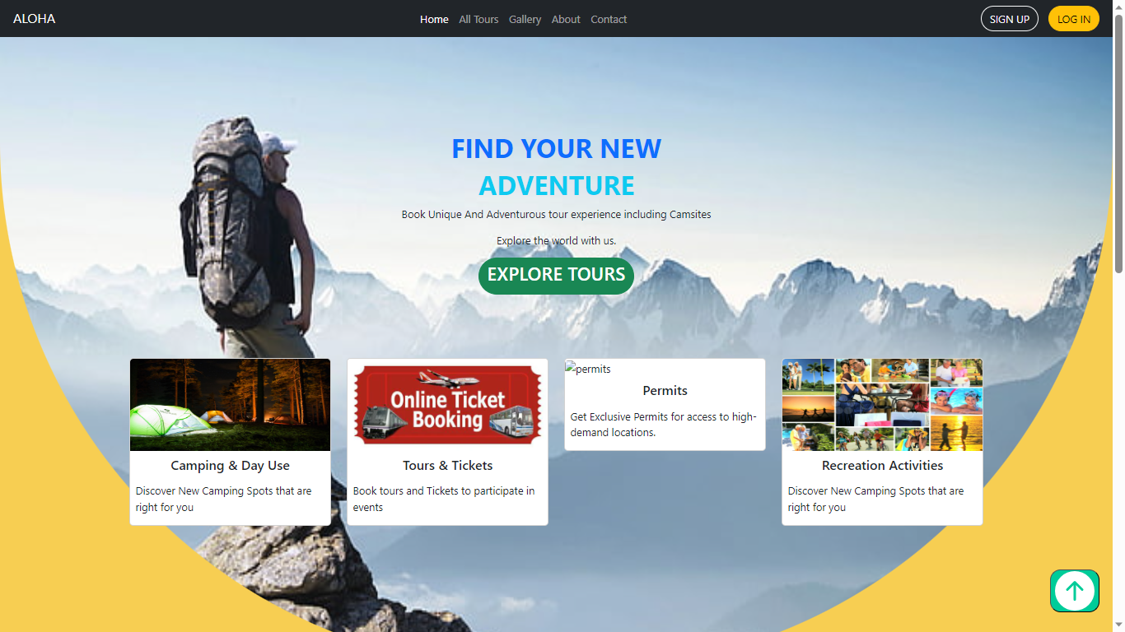

gallery:  About:



Contact:



User register

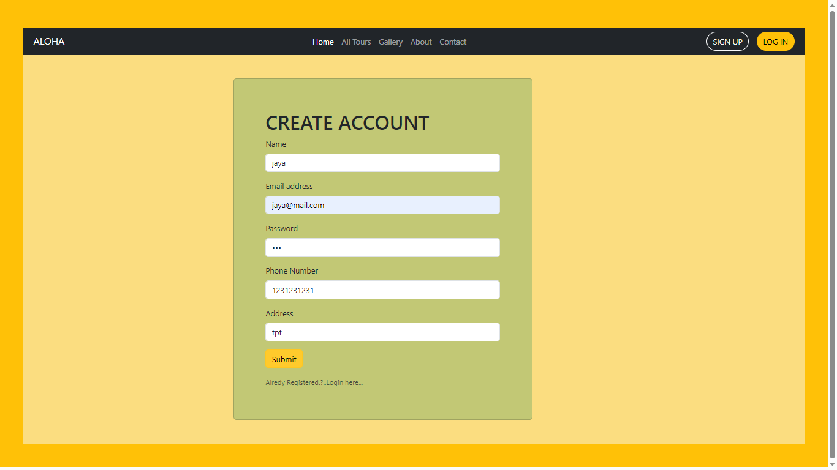User login page:

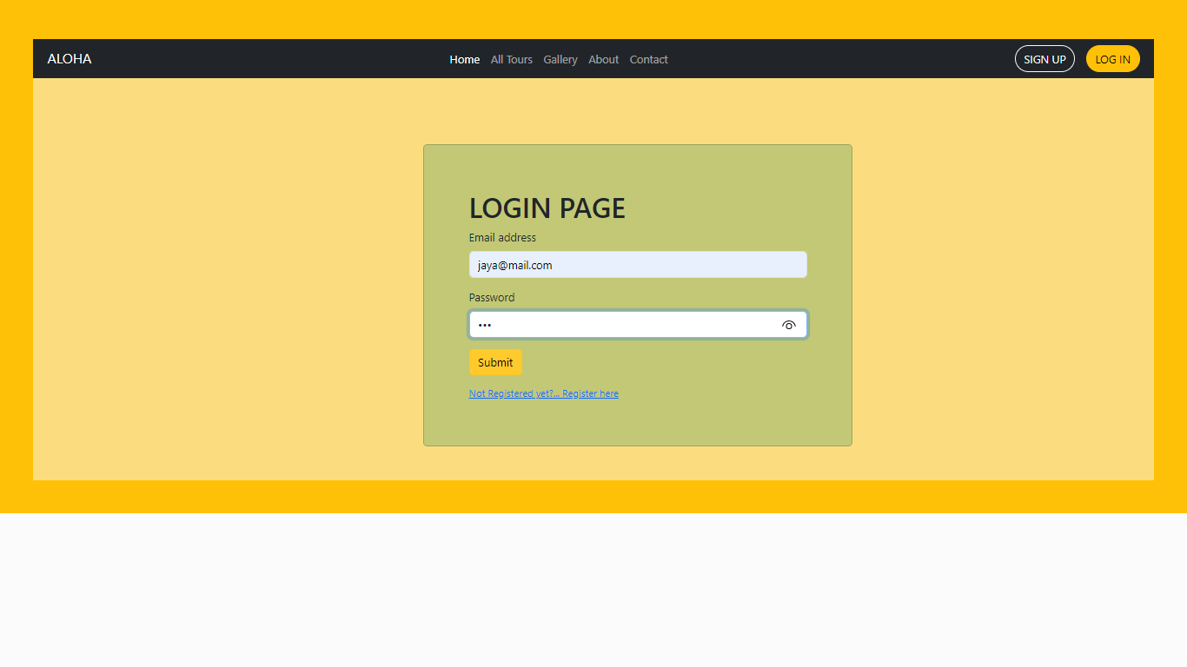

admin login 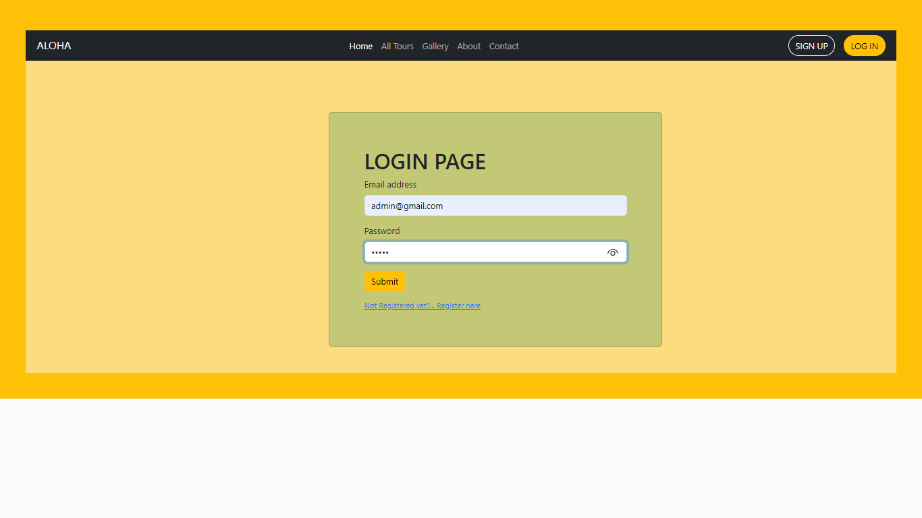Admin Home page:



Add tours

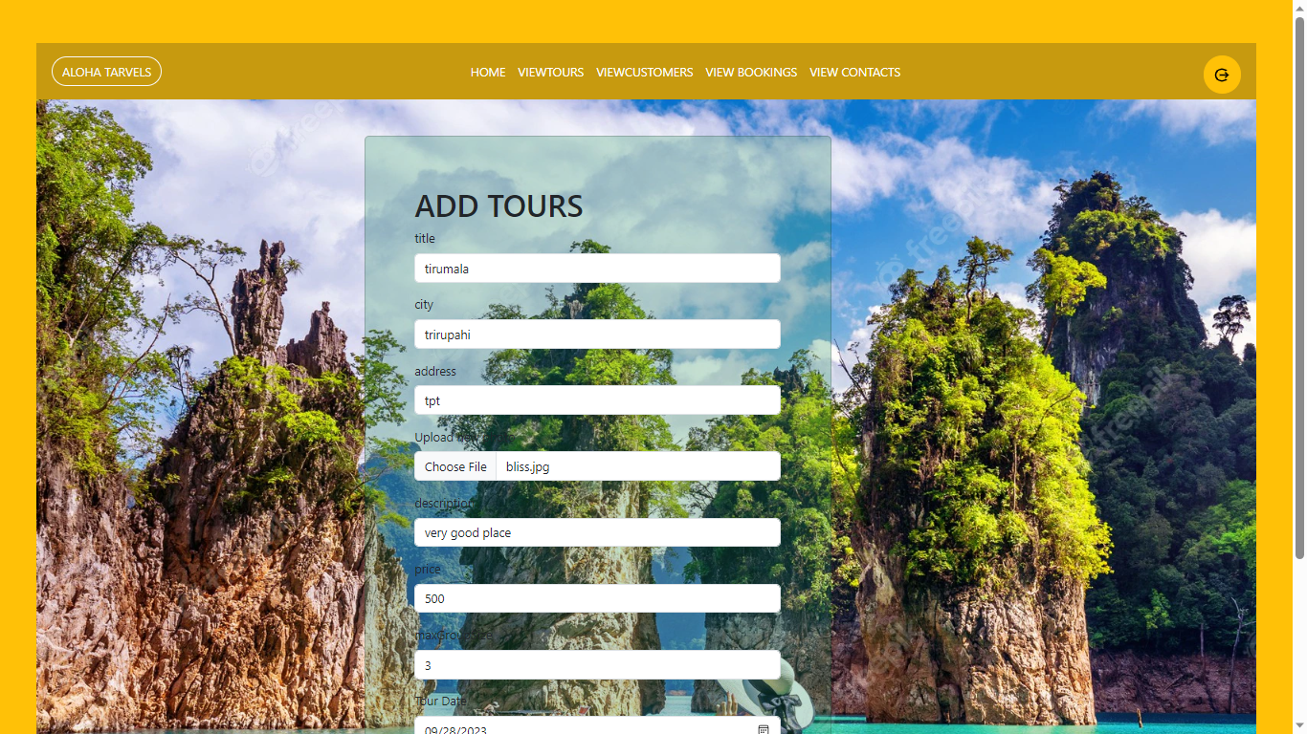View tours:

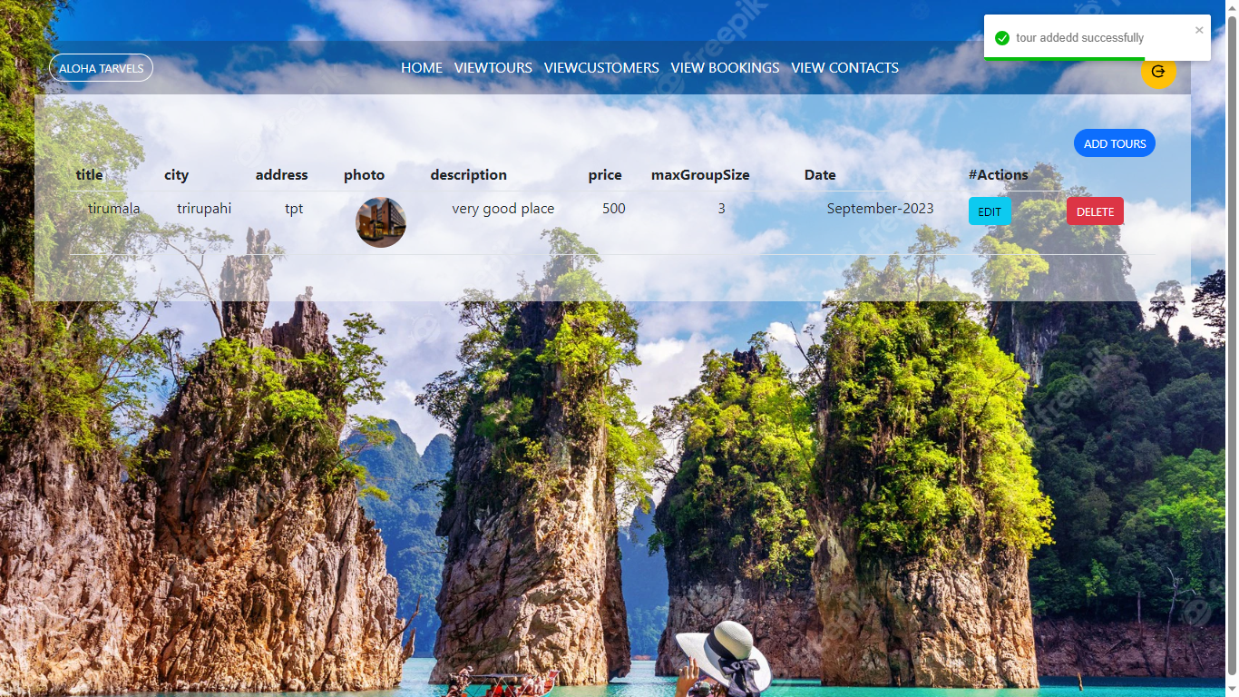View customer:

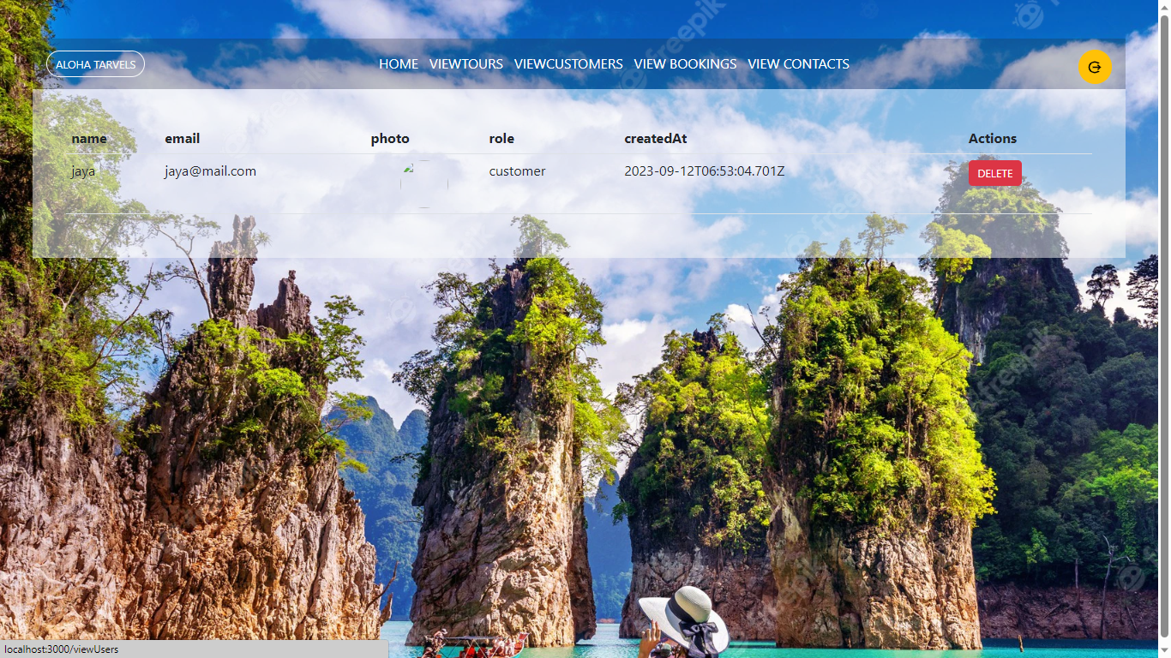

User can view the tours:

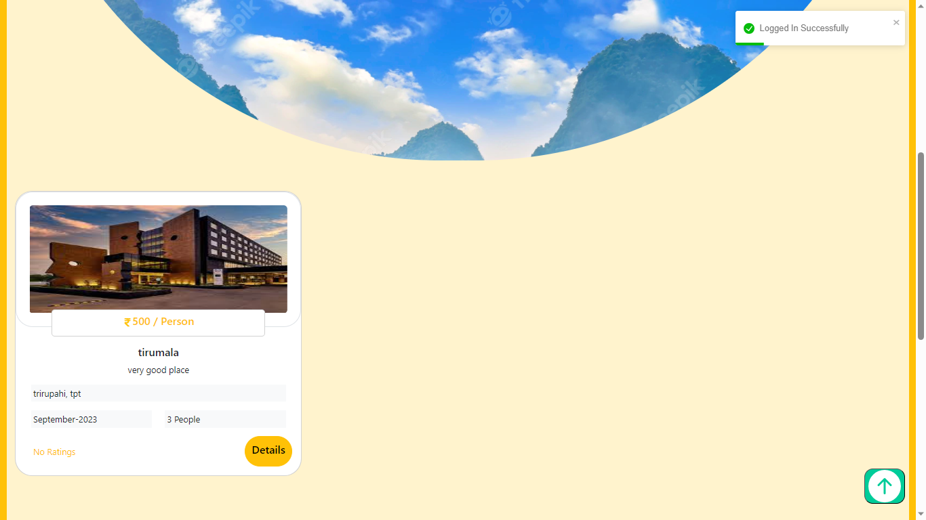Details of tours:

 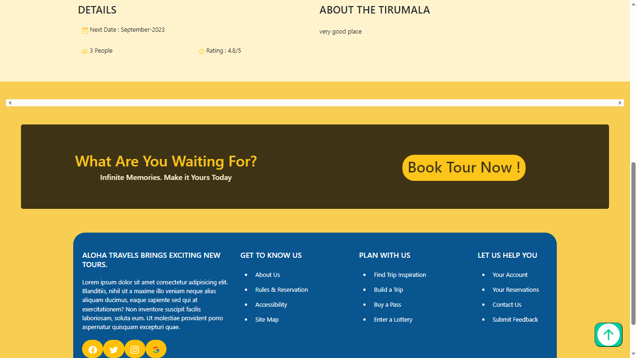

Payment

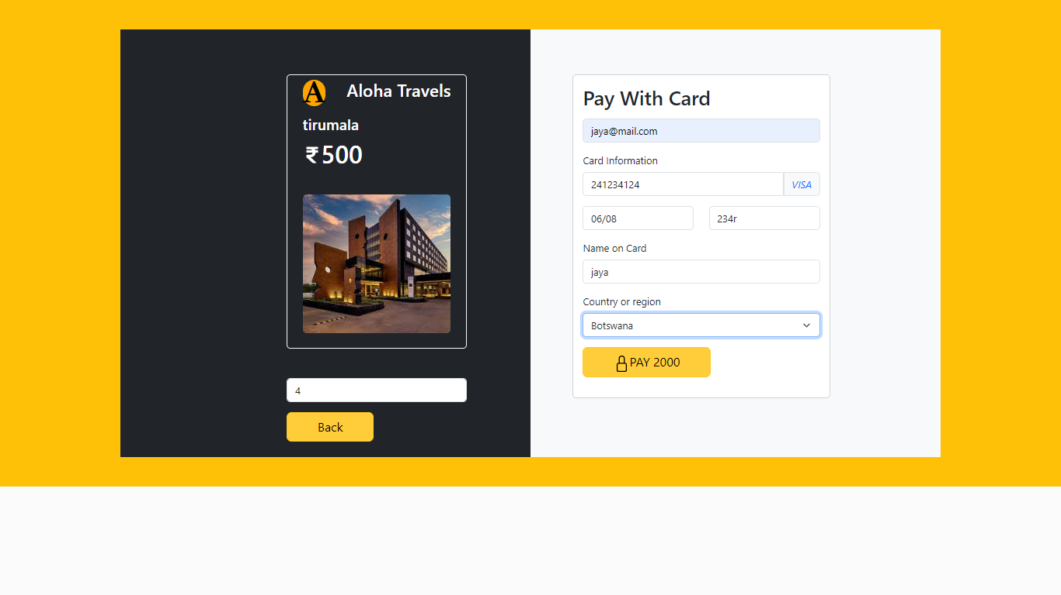

My bookings:

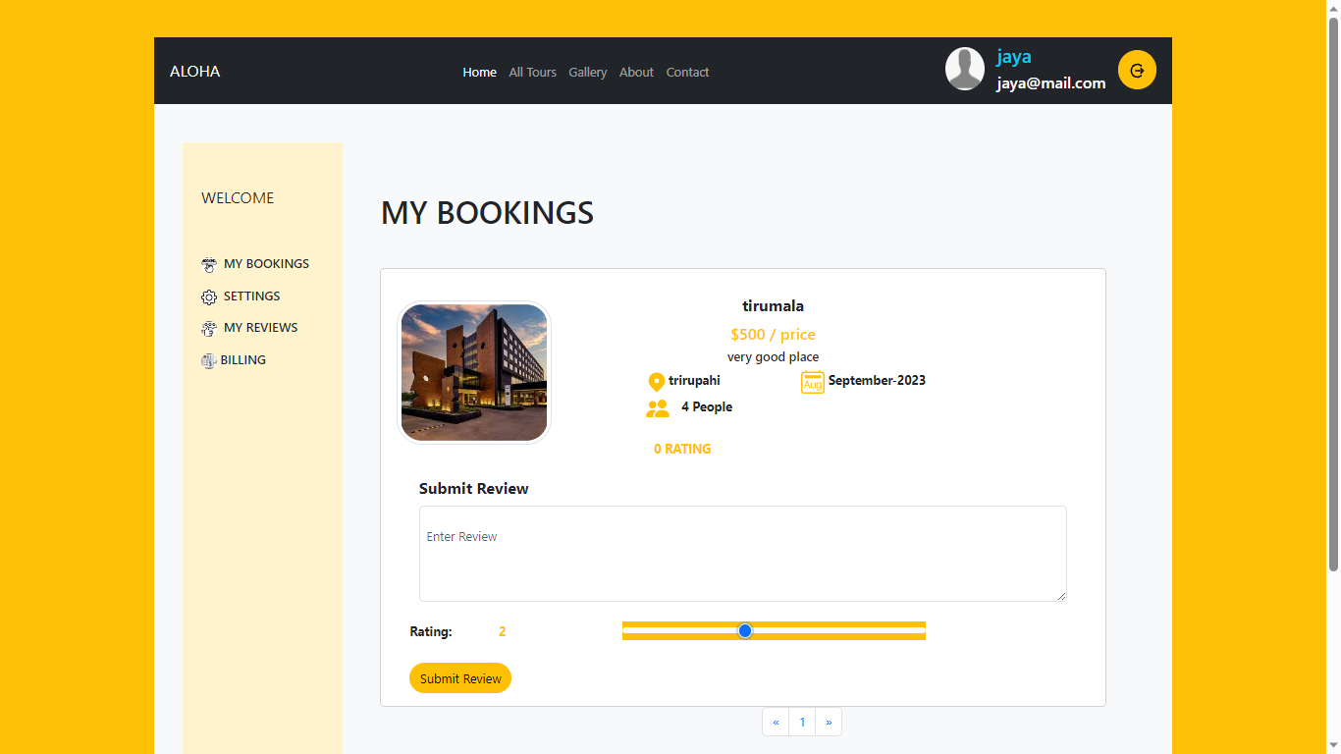

Setting: 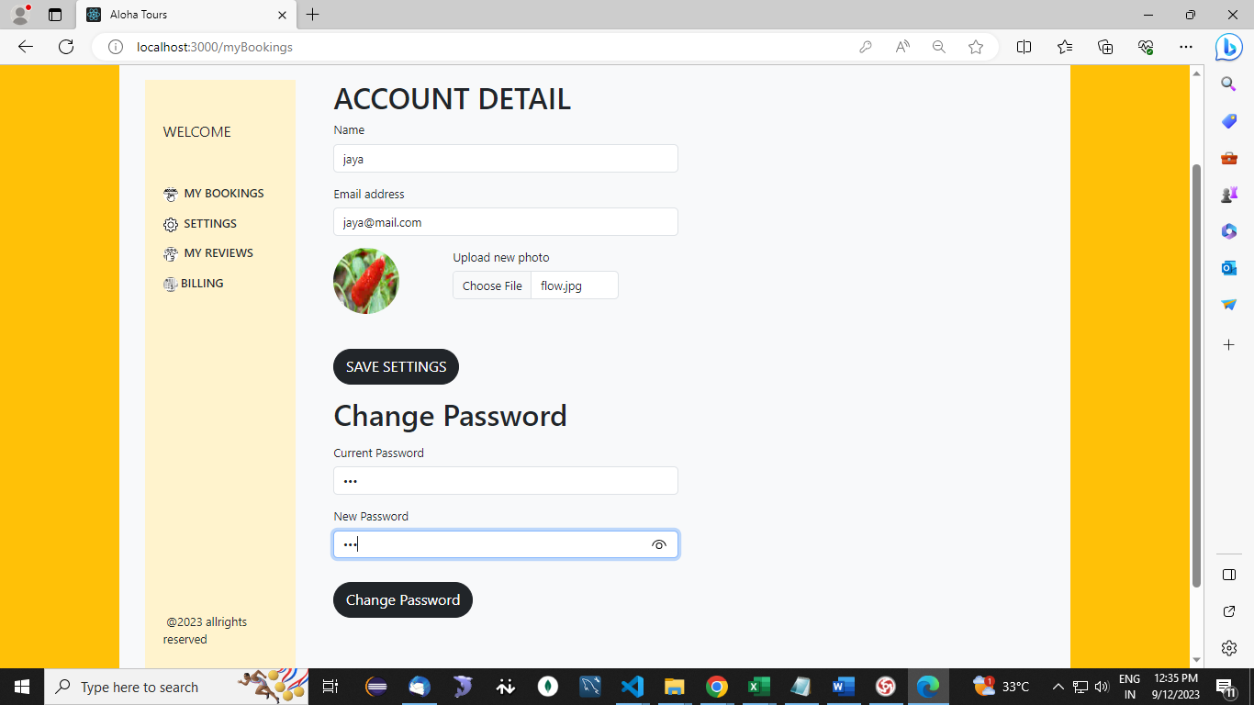

Billing details:

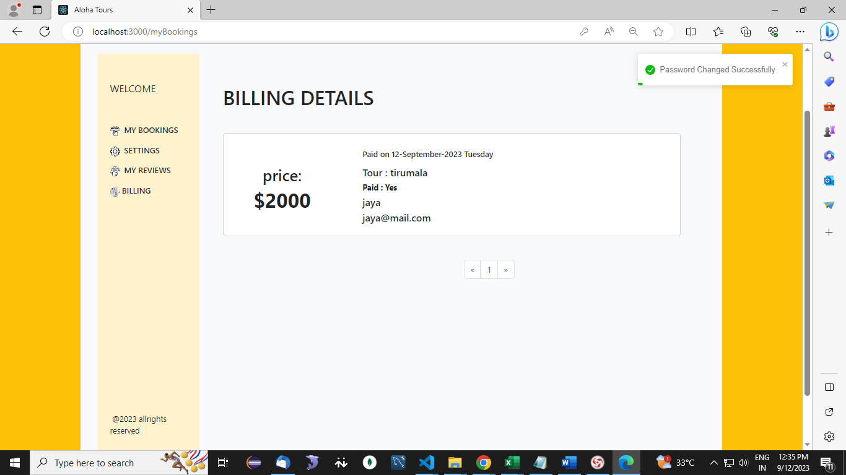

**CONCLUSION**

In conclusion, when it comes to tours and travels, the journey begins with the first step – viewing tours and making bookings. This initial excitement is followed by the seamless process of making payments for the chosen tour, ensuring a hassle-free experience. However, the adventure doesn't end there; it extends to the post-trip phase where travelers have the opportunity to share their valuable feedback through reviews. These reviews not only help improve the quality of future tours but also serve as a source of inspiration for fellow travelers. Thus, from viewing tours to booking, making payments, and providing reviews, the world of tours and travels is a dynamic and rewarding one that fosters exploration and connection.

**REFERENCES**

1. R. E. Mayer, “Fifty Years of Creativity Research”, Handbook of Creativity, R. J. Sternberg, Ed. Cambridge: Cambridge University Press, 1999, pp. 449–460.
2. E. A. Carroll, C. Latulipe, R. Fung, and M. Terry, “Creativity Factor Evaluation: Towards A Standardised Survey Metric for Creativity Support,” 7th ACM Conference on Creativity and Cognition, ACM Press, New York, 2009, pp. 127–136.
3. D. Janssen, T. Schlegel, M. Wissen, and J. Ziegler, “MetaCharts - Using Creativity Methods in A CSCW Environment,” Human- Computer Interaction Theory and Practice (Part II), CRC Press, 2003, pp. 939–943.
4. T.R.G. Green, Cognitive Dimensions of Notations, Cambridge University Press, Cambridge, 1989.
5. M. A. Boden, “Artificial Intelligence Creativity and Artificial Intelligence,” Artificial Intelligence, vol. 103, no. 1–2, Amsterdan, 1998, pp. 347– 356.
6. D. L. Dean, J. M. Hender, T. L. Rodgers, and E. L. Santanen, “Identifying Quality, Novel, and Creative Ideas: Constructs and Scales for Idea Evaluation,” Jounral of Association for Information Systems, vol. 7, no. 10, IEEE Press, New York, 2006, pp. 646–698.